**Batch: D2 Roll No.: 25**

**Experiment / assignment / tutorial No. 3**

**Grade: AA / AB / BB / BC / CC / CD /DD**

**Signature of the Staff In-charge with date**

|  |
| --- |
| **TITLE:**  Menu driven program. |

**AIM:** Write a menu driven program for following option

a.To find whether a number is palindrome or not. (e.g. 1221 is palindrome)

b. To calculate the sum of the Fibonacci series up to ‘n’ terms(use do-while loop only)

c. To find the numbers and sum of all integer between 100 and 200 which are divisible by both 3 & 5.(use for loop only)

______**________________________________________________________________**

**Expected OUTCOME of Experiment:**

**_____________________________________________________________________**

**Books/ Journals/ Websites referred:**

1. Programming in C, second edition, Pradeep Dey and Manas Ghosh, Oxford University Press.
2. Programming in ANSI C, fifth edition, E Balagurusamy, Tata McGraw Hill.
3. Introduction to programming and problem solving , G. Michael Schneider ,Wiley India edition.
4. [**http://cse.iitkgp.ac.in/~rkumar/pds-vlab/**](http://cse.iitkgp.ac.in/~rkumar/pds-vlab/)

**_____________________________________________________________________**

**Problem Definition:**

The program accepts a choice from the user using a switch case statement and generates output accordingly.

**Choice a**: The program checks whether a given numbered by user is palindrome or not.If a number remains same, even if we reverse its digits then the number is known as palindrome number. For example, 12321 is a palindrome number because it remains same if we reverse its digits.

**Choice b:** Sum of Fibonacci series up to n terms will be generated. Fibonacci series is a series in which each number is the sum of the last two preceding numbers. The first two terms of a Fibonacci series are 0 and 1.(use while loop only)

**Example:**

Input: n = 5

Output: 7

Explanation: 0 + 1 + 1 + 2 + 3 = 7

**Choice c:** To find the numbers and sum of all integer between 100 and 200 which are divisible by both 3 & 5.(use for loop only)

**Algorithm:**

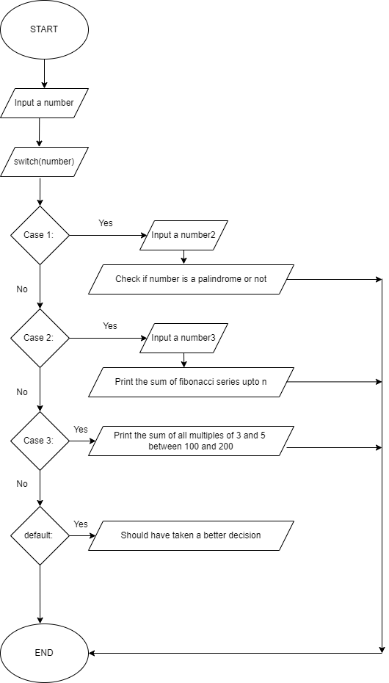

**Implementation details:**

**#include <stdio.h>**

**void main()**

**{**

**printf("Press 1 for palindrome, 2 for Fibonacci series, 3 for the sum of numbers from 100 to 200 divisible by 3 or 5 \n");**

**int choice;**

**scanf("%d", &choice);**

**switch(choice)**

**{**

**case 1:**

**printf("Enter a number to check if its palindrome or not: ");**

**int num;**

**scanf("%d", &num);**

**int c = num;**

**int rev = 0;**

**int d;**

**while(num != 0)**

**{**

**d = num % 10;**

**rev = rev * 10 + d;**

**num = num / 10;**

**}**

**if(rev == c)**

**{**

**printf("Number entered is a palindrome number");**

**}**

**else**

**{**

**printf("The number is not a palindrome number");**

**}**

**break;**

**case 2:**

**printf("Enter the value till which you want to print the fibonacci series: ");**

**num = 0;**

**scanf("%d", &num);**

**int a = 0;**

**int b = 1;**

**int c = 0;**

**if(n == 0)**

**printf("Enter a positive number: ");**

**if(n == 1)**

**printf("0");**

**if(n == 2)**

**printf("1");**

**if(n == 3)**

**printf("0 1");**

**if(n == 4)**

**{**

**printf("0 1");**

**num = num -2;**

**do**

**{**

**c = a + b;**

**a = b;**

**b = c;**

**printf("%d", c);**

**num = num - 1;**

**}**

**while(num != 0);**

**}**

**break;**

**case 3:**

**int sum = 0;**

**int i = 0;**

**printf("The number divisible by 3 and 5 ranging from 100 to 200 are: ");**

**for(i = 100; i <= 200; i ++)**

**{**

**if(i % 3 == 0 || i % 5 == 0)**

**{**

**printf("%d ", i);**

**sum = sum + i;**

**}**

**}**

**printf("Sum: %d", sum);**

**break;**

**default:**

**printf("Shall have made a better choice");**

**}**

**}**

**Output(s):**

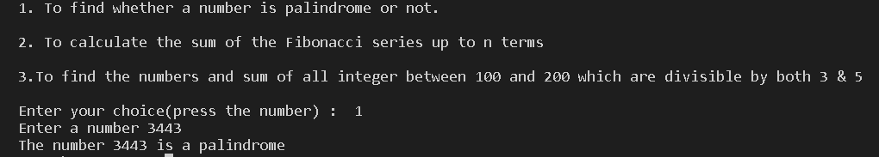

**Conclusion:**

We are able to create a menu driven program which gives us the ability to carry out a specific function out of a list of functions.

**Post Lab Descriptive Questions**

**Write menu driven code for the following:**

The program allows a user to enter five numbers and then asks the user to select a choice from a menu. The menu should offer the following options –

1. Display the smallest number entered

2. Display the largest number entered

3. Display the sum of the five numbers entered

4. Display the average of the five numbers entered.

5. Exit

#include <stdio.h>

void main()

{

int a,b,c,d,e,small,big,sum,choice;

float avg,s;

printf("Enter five numbers\n");

scanf("%d %d %d %d %d",&a,&b, &c, &d, &e);

printf("1. Find the smallest number\n\n");

printf("2. Print the biggest number\n\n");

printf("3. Print the sum of the numbers\n\n");

printf("4. Print the average of the numbers\n\n");

printf("5. Exit\n\n");

printf("Enter your choice: ");

scanf("%d", &choice);

switch (choice)

{

case 1:

small = ( (a<b && a<c && a<d && a<e) ? a : (b<c && b<d && b<e) ? b : (c<d && c<e)? c : (d<e)? d : e );

printf("Smallest Number is : %d",small);

break;

case 2:

big = ( (a>b && a>c && a>d && a>e) ? a : (b>c && b>d && b>e) ? b : (c>d && c>e)? c : (d>e)? d : e );

printf("Biggest Number is : %d",big);

break;

case 3:

sum = a + b + c + d + e;

printf("The sum of the five numbers you have entered is %d",sum);

break;

case 4:

s= (a+b+c+d+e);

avg=s/5;

printf("The average of the numbers entered is %f", avg);

break;

case 5:

{

printf("You have exited from the software");

}

break;

default:

{

printf("Please enter a valid input");

}

}

return 0;

}

**Date: _____________ Signature of faculty in-charge**